OPERATION FALSE ASSURANCE

Team Name | BYEBUST
Phase Number / Title | Phase 2 / OFA P2-03 - NetSupport Gateway
Incident Date | 2025-10-03
Date Submitted | 2026-08-22

REPORT SCORING
No. | Category | Percentage | Points
1 | Executive Summary | 10% | 100
2 | Incident Timeline & Attack Reconstruction | 15% | 150
3 | Victim & Infrastructure Identification | 10% | 100
4 | Technical Investigation, Evidence & Attack Analysis | 55% | 550
5 | Containment, Eradication & Recovery Recommendations | 5% | 50
6 | Report Quality & Professional Presentation | 5% | 50
 | TOTAL | 100% | 1,000
Evidence Requirement: Major findings must be supported by Security Onion, Kibana, Elasticsearch, Zeek, Suricata, or other authorized evidence. Unsupported findings may receive no more than 50% of the available points for that finding.

1. EXECUTIVE SUMMARY
10% - 100 Points
Summarize the activity observed during this phase. State what happened, the affected system, the nature of the malicious activity, and the operational significance.
This report documents a single, focused finding from Operation False Assurance Phase 2: identification of the domain that resolved to the NetSupport Manager remote-access-trojan (RAT) gateway used by the infected workstation 10.8.20.101, along with the gateway's IP address and destination port.
Zeek DNS logs show the infected host queried the domain westford-systems.icu, which resolved to 38.146.28.242 - the same IP that received 48 NetSupport Manager RAT beacon connections on TCP/1203 (Suricata rule ET REMOTE_ACCESS NetSupport Remote Admin Checkin).
This confirms westford-systems.icu as attacker-controlled infrastructure fronting the RAT command-and-control (C2) channel, and should be treated as a high-confidence indicator of compromise.

2. INCIDENT TIMELINE AND ATTACK RECONSTRUCTION
15% - 150 Points
Record the significant events in chronological order. Use UTC for all timestamps.
Date / Time (UTC) | Source | Destination | Protocol / Port | Activity / Observation
2025-10-03 09:12:56 UTC | 10.8.20.101 | 10.8.20.1 (internal DNS) | UDP/53 (DNS) | DNS query for westford-systems.icu; A record answer NOERROR
2025-10-03 ~09:49-09:58 UTC | 10.8.20.101 | 38.146.28.242 | TCP/1203 (HTTP) | NetSupport Manager RAT beacon/check-in traffic (48 events) to /fakeurl.htm - destination IP matches the resolved answer for westford-systems.icu

Attack Reconstruction
Describe how the activity developed during the phase, what the attacker accomplished, and how the available evidence supports the conclusion.
At approximately 09:12:56 UTC, host 10.8.20.101 issued a DNS A-record query for westford-systems.icu to the internal resolver 10.8.20.1, which returned a single answer: 38.146.28.242 (Figure 2).
Approximately thirty-seven minutes later (~09:49-09:58 UTC), the same host began exchanging NetSupport Manager RAT beacon traffic (CMD=POLL / CMD=ENCD to /fakeurl.htm) with that exact IP address, 38.146.28.242, over TCP port 1203 (Figure 1).
Correlating the DNS answer with the connection metadata confirms westford-systems.icu is the domain name behind the NetSupport RAT gateway; a follow-up query restricted to this domain (Figure 3) shows it resolves exclusively to this one IP, with no other observed A records.
No other domain in the dataset was observed resolving to 38.146.28.242, and no other IP was observed for westford-systems.icu, giving a one-to-one, high-confidence mapping between domain and gateway.

3. VICTIM AND INFRASTRUCTURE IDENTIFICATION
10% - 100 Points

Affected System
IP Address | 10.8.20.101
Hostname | Not Determined
User Account | Not Determined
Operating System | Not Determined
Active Directory Domain | Not Determined
System Role
Status | Confirmed Compromised - active NetSupport Manager RAT C2 channel to a gateway resolved via westford-systems.icu
Status: Confirmed Compromised / Suspected Compromised / Targeted / Scanned / Not Determined

Relevant Infrastructure
Type | Domain / IP Address | Port | Purpose / Observation
C2 - Remote Access Tool (Domain) | westford-systems.icu | 1203 | Domain observed resolving to the NetSupport gateway IP
C2 - Remote Access Tool (Gateway IP) | 38.146.28.242 | 1203 | NetSupport Manager RAT gateway; resolved answer for westford-systems.icu
Internal DNS Resolver | 10.8.20.1 | 53 | Resolver used by the infected host for the westford-systems.icu lookup

4. TECHNICAL INVESTIGATION, EVIDENCE AND ATTACK ANALYSIS
55% - 550 Points
This section contains the main technical findings. Each significant conclusion should be supported by evidence.

4.1 Analyst Findings
No. | Finding / Objective | Answer / Result | Evidence Ref.
1 | Which domain resolved to the NetSupport gateway, and what gateway IP address and destination port were used? | Domain: westford-systems.icu -> Gateway IP: 38.146.28.242 -> Destination Port: 1203/TCP | Figures 1-3

4.2 Malware / Tool Identification
Malware / Tool / Technique | Evidence | Confidence
NetSupport Manager v1.3 (legitimate remote-support tool abused as a RAT) | Suricata rule "ET REMOTE_ACCESS NetSupport Remote Admin Checkin" (48 hits) to 38.146.28.242:1203; HTTP User-Agent "NetSupport Manager/1.3"; gateway IP resolves from domain westford-systems.icu (Figures 1-3) | High
Technical analysis:
The NetSupport Manager RAT beacon connects to a fixed non-standard port (TCP/1203) using a static beacon path (/fakeurl.htm). DNS resolution for the gateway domain (westford-systems.icu) was performed once by the infected host shortly before the beacon traffic began, indicating the domain was hard-coded into the RAT configuration rather than dynamically generated (no DGA-style query pattern was observed).

4.3 Network Activity
Time (UTC) | Source IP | Destination IP | Port | Protocol | Domain / Host | Observation
2025-10-03 09:12:56 UTC | 10.8.20.101 | 10.8.20.1 | 53 | DNS | westford-systems.icu | DNS A-record query; single answer 38.146.28.242, NOERROR
2025-10-03 ~09:49-09:58 UTC | 10.8.20.101 | 38.146.28.242 | 1203 | HTTP (NetSupport Manager) | westford-systems.icu (resolved) | 48 RAT beacon events (CMD=POLL/CMD=ENCD) to /fakeurl.htm
Analysis:
The DNS query and the subsequent TCP/1203 connections both originate from the same host, 10.8.20.101, and target the same IP, 38.146.28.242 - directly linking the resolved domain to the observed RAT gateway.

4.4 Command-and-Control Activity
C2 Domain / IP | Port | Protocol | First Seen | Observation
westford-systems.icu / 38.146.28.242 | 1203 | HTTP (NetSupport Manager) | ~2025-10-03 09:49 UTC (earliest of most-recent 10 of 48 events reviewed) | NetSupport Manager RAT beacon (CMD=POLL, CMD=ENCD) to /fakeurl.htm; gateway IP confirmed via DNS resolution of westford-systems.icu (single A record, no other domains observed resolving to this IP)
Assessment:
A single, unambiguous domain-to-IP mapping was established: westford-systems.icu resolves only to 38.146.28.242, and 38.146.28.242 was queried by no other domain in the dataset. This is a high-confidence C2 gateway indicator.

4.5 Files and Payloads
Filename | Source / URL | Type | Observation
Use “Not Determined” when the exact filename or content cannot be confirmed from the available evidence.

4.6 Credential Collection / Exfiltration
Collection Method
Information Collected
Exfiltration Method
Destination
Protocol / Port
Assessment:
________________________________________________________________________________
________________________________________________________________________________

4.7 Lateral Movement
Time (UTC) | Source | Destination | Port / Protocol | Activity
State whether the destination was merely contacted, targeted, or confirmed compromised.
________________________________________________________________________________
________________________________________________________________________________

4.8 Ransomware Activity
Ransomware Family
Initial Source
First Target
Propagation Protocol
Destination Port
Exploit / Technique
Additional Propagation Sources
Affected Systems
First Observed Time
Last Observed Time
Assessment:
________________________________________________________________________________
________________________________________________________________________________
________________________________________________________________________________

4.9 Indicators of Compromise
Indicator | Type | Purpose / Assessment | Recommended Action
westford-systems.icu | Domain | Resolves to the NetSupport Manager RAT gateway | Block/sinkhole domain; add to DNS blocklist
38.146.28.242:1203 | C2 IP:Port | NetSupport Manager RAT gateway (resolved from westford-systems.icu) | Block at perimeter firewall/proxy; add to blocklist

4.10 Investigation Evidence
Query / Filter Used:
Security Onion Hunt (Elasticsearch): event.dataset:zeek.dns && dns.resolved_ip:"38.146.28.242" (time range: last 365 days)
Finding:
Exactly one DNS record matches: source.ip 10.8.20.101, dns.query.name = westford-systems.icu, dns.resolved_ip = 38.146.28.242, response NOERROR - confirming this domain as the one that resolved to the RAT gateway.

Evidence Reference: Figure 2
Kibana / Elasticsearch
Alerts / Suricata
Time (UTC) | Alert | Source | Destination | Remarks
2025-10-03 ~09:49-09:58 UTC (48 events) | ET REMOTE_ACCESS NetSupport Remote Admin Checkin | 10.8.20.101:63910 | 38.146.28.242:1203 | Confirms RAT gateway destination and port
Zeek Logs Used
- [x] conn
- [x] dns
- [x] http
- [ ] ssl / tls
- [ ] smtp
- [ ] files
- [ ] dhcp
- [ ] kerberos
- [ ] smb
- [ ] other: Suricata eve.json alerts (imported)
Relevant observation:
A reverse check - event.dataset:zeek.dns && dns.query.name:"westford-systems.icu" | groupby dns.resolved_ip - returns exactly one grouped result (38.146.28.242, count 1), confirming a clean one-to-one domain-to-IP mapping with no additional A records observed (Figure 3).

4.11 Evidence Register
Evidence No. | Description | Source
E-01 | Security Onion Hunt - rule.name "ET REMOTE_ACCESS NetSupport Remote Admin Checkin" grouped by source.ip/destination.ip: confirms 48/48 events from 10.8.20.101 to 38.146.28.242:1203 (the NetSupport gateway and port). | Security Onion
E-02 | Security Onion Hunt - event.dataset:zeek.dns && dns.resolved_ip:"38.146.28.242": Total Found 1, showing dns.query.name = westford-systems.icu resolved to the gateway IP. | Kibana
E-03 | Security Onion Hunt - event.dataset:zeek.dns && dns.query.name:"westford-systems.icu" | groupby dns.resolved_ip: confirms the domain resolves exclusively to 38.146.28.242 (count 1, no other answers). | Suricata
E-04 |  | Zeek
E-05 |  | Other
Each screenshot should include a short caption explaining what it shows.

4.12 MITRE ATT&CK Mapping
Tactic | Technique | Technique ID | Evidence
Command and Control | Remote Access Software | T1219 | NetSupport Manager RAT beacon traffic to 38.146.28.242:1203 (Figure 1)
Command and Control | Application Layer Protocol: Web Protocols | T1071.001 | HTTP-based C2 beacon (CMD=POLL/CMD=ENCD to /fakeurl.htm)
Command and Control | Dynamic Resolution / Domain Fronting Infrastructure (DNS) | T1568 | Gateway IP resolved via attacker-registered domain westford-systems.icu (Figures 2-3)

5. CONTAINMENT, ERADICATION AND RECOVERY
5% - 50 Points
Provide recommendations based on the findings from this phase.

Immediate Actions
1. Block/sinkhole the domain westford-systems.icu and the IP 38.146.28.242:1203 at the DNS resolver and perimeter firewall.
2. Alert on any further NetSupport Manager User-Agent traffic or connections to TCP/1203 across the environment.
3. Correlate this gateway IOC with the broader Phase 2 investigation (infected workstation 10.8.20.101).

Additional Recommendations
Network:
Add westford-systems.icu and 38.146.28.242 to DNS sinkhole and firewall blocklists.
Endpoint:
Hunt for NetSupport Manager artifacts (installed software, running processes) on 10.8.20.101 and peer hosts.
Accounts / Credentials:
Not applicable to this focused finding.
Active Directory, if applicable:
Not Determined.
Recovery:
See the main Phase 2 investigation report for host-level recovery recommendations.

6. CONCLUSION
Provide the team’s final assessment of the phase. State what happened, what system was affected, what the attacker accomplished, the evidence supporting the conclusion, the impact, and how this phase relates to the larger incident.
This focused investigation confirmed that the domain westford-systems.icu resolved to 38.146.28.242, the IP address serving as the NetSupport Manager RAT gateway for infected workstation 10.8.20.101.
The gateway received 48 RAT beacon connections on TCP port 1203, using the CMD=POLL/CMD=ENCD protocol to the path /fakeurl.htm, consistent with active remote-access C2 activity.
The domain-to-IP mapping is unambiguous: westford-systems.icu resolves to exactly one IP, and that IP was queried by no other domain in the dataset, giving high confidence in this indicator of compromise.
This finding supports the broader Phase 2 conclusion that 10.8.20.101 was compromised and actively used for attacker remote access.
This finding should be read alongside the main Phase 2 report (infected workstation and DNS resolver identification, and suspicious TLS destinations).

7. EVIDENCE LIMITATIONS
List any information that could not be confirmed from the available data. Do not present assumptions as confirmed facts.
The exact first DNS query time for westford-systems.icu and the full 48-event NetSupport beacon window were not independently re-verified beyond what was already established in the main Phase 2 report.
Whether westford-systems.icu is also used for any other C2 function (e.g., secondary payload delivery) beyond the observed RAT gateway role was not investigated in this pass.

8. APPENDICES

Appendix A - Investigation Queries
Query:
Security Onion Hunt: event.dataset:zeek.dns && dns.resolved_ip:"38.146.28.242" (Last 365 days) - identifies the domain that resolved to the NetSupport gateway IP.
Query:
Security Onion Hunt: event.dataset:zeek.dns && dns.query.name:"westford-systems.icu" | groupby dns.resolved_ip (Last 365 days) - confirms the domain resolves exclusively to 38.146.28.242.
Query:
Security Onion Hunt: rule.name:"ET REMOTE_ACCESS NetSupport Remote Admin Checkin" | groupby source.ip destination.ip (Last 365 days) - confirms the gateway IP and destination port (1203) via connection metadata.

Appendix B - Figures and Screenshots
Use sequential figure numbers. Each figure should include a short caption describing what the evidence demonstrates.
Figure 1

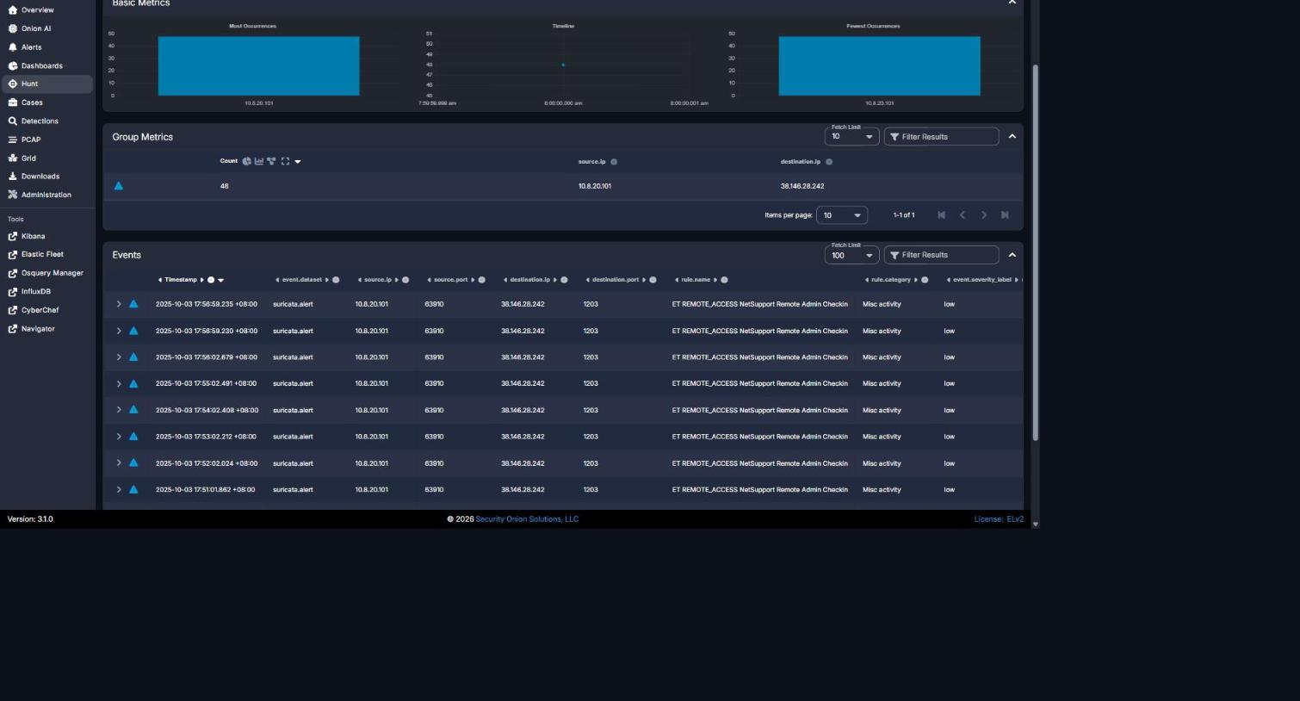
Security Onion Hunt - NetSupport rule grouped by source.ip/destination.ip: 48/48 events, 10.8.20.101 -> 38.146.28.242:1203 (gateway IP and destination port).
Figure 2

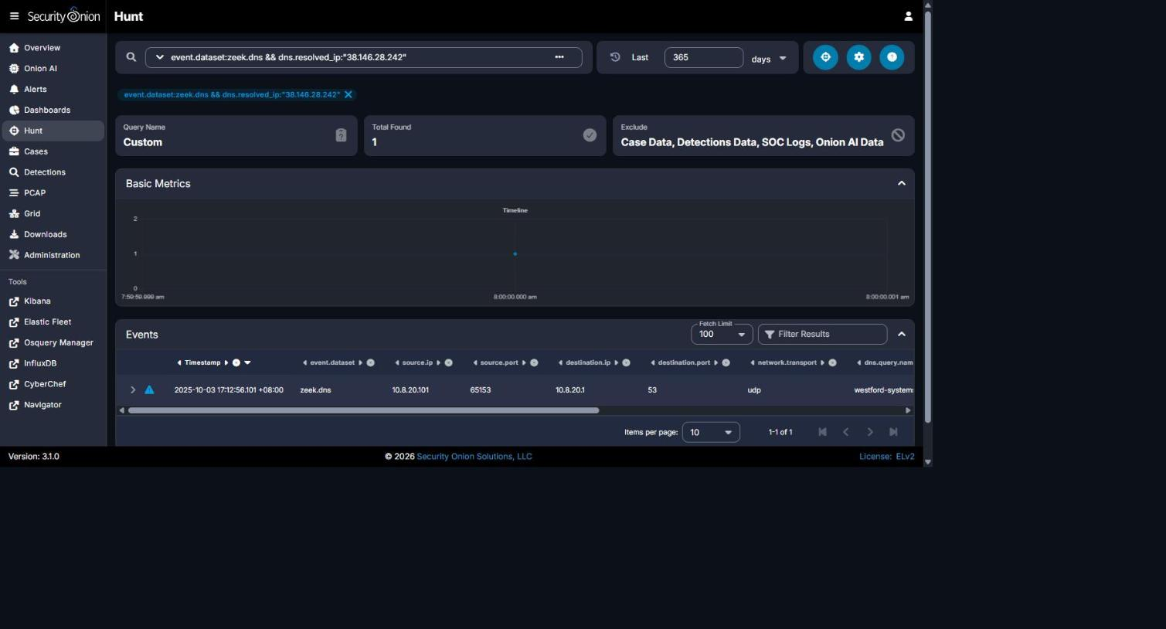
Security Onion Hunt - zeek.dns filtered by dns.resolved_ip:"38.146.28.242": Total Found 1, dns.query.name = westford-systems.icu.
Figure 3
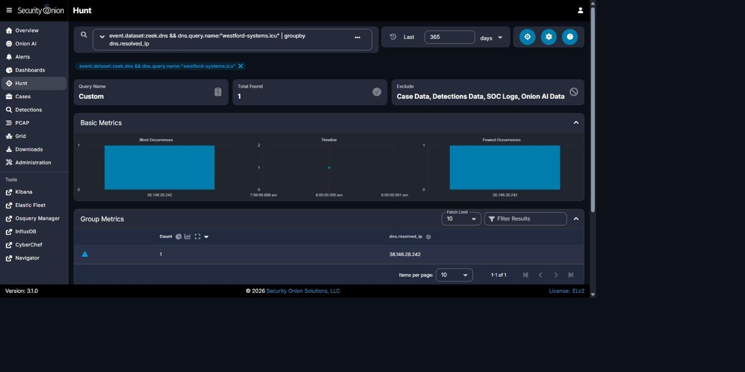
Security Onion Hunt - zeek.dns for dns.query.name:"westford-systems.icu" grouped by dns.resolved_ip: confirms exclusive resolution to 38.146.28.242.
Figure | Caption / Description
Figure 1 | Security Onion Hunt - rule.name "ET REMOTE_ACCESS NetSupport Remote Admin Checkin" grouped by source.ip/destination.ip: confirms 48/48 events from 10.8.20.101 to 38.146.28.242:1203 (gateway IP and destination port).
Figure 2 | Security Onion Hunt - event.dataset:zeek.dns && dns.resolved_ip:"38.146.28.242": Total Found 1, showing dns.query.name = westford-systems.icu (the domain that resolved to the gateway).
Figure 3 | Security Onion Hunt - event.dataset:zeek.dns && dns.query.name:"westford-systems.icu" | groupby dns.resolved_ip: confirms the domain resolves exclusively to 38.146.28.242.

REPORT QUALITY REQUIREMENTS
5% - 50 Points
- Clear and logical organization
- Correct technical terminology
- Accurate use of timestamps
- Readable screenshots
- Properly labeled tables and figures
- Consistent evidence references
- Clear distinction between confirmed facts and analyst inference
- Professional presentation and readability

SUBMISSION INSTRUCTIONS
1. Submit one report for each phase designated as Report-Required.
2. Submit the final report in PDF format unless otherwise directed.
3. Clearly indicate the team name, phase number, and phase title.
4. Use UTC for timestamps.
5. Major findings must be supported by evidence.
6. Screenshots must be numbered and captioned.
7. Do not include executable malware samples in the report.
8. State 'Not Determined' when a finding cannot be confirmed.
9. Ensure all screenshots, tables, and text are readable.
10. Reports must be submitted before the deadline announced by exercise control.
Evidence Rule: A correct finding without supporting Security Onion, Kibana, Elasticsearch, Zeek, Suricata, or other authorized evidence may receive no more than 50% of the points assigned to that finding. Incorrect or fabricated evidence receives zero points for the affected finding.

